Restlet
Create a restlet which will be called from NSPOS (they will use an address for that). Create a script, I can reuse the code from some other restlet, check: NS_RL_ZinreloLoyalty.js

Create script
Respect the get, post, put and delete syntax given:
function doGet(requestParams) {

}

function doPost(requestBody) {

}

function doPut(requestBody) {

}

function doDelete(requestParams) {

}

return {
'get': doGet,
put: doPut,
post: doPost,
'delete': doDelete
};

Always return JSON stringified objets:
return JSON.stringify({
result: 'not created'
});

Calling restlet
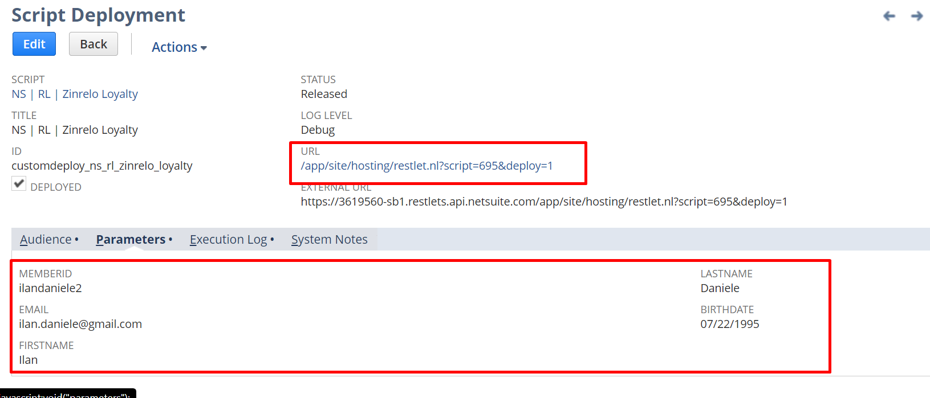
Enter to the URL given.
This calls “get” call.
How do I call post call?

Parameters
They can be modified in there, or we can pass them onto our restlet call.
Inside our code, we get the parameters on our restlet with line:
nRuntime.getCurrentScript().getParameter('custscript_member_id');

